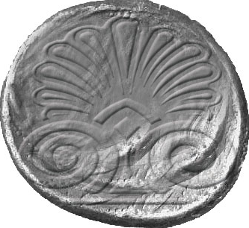
ESWC
29 May – June 1, 2005, Hersonissos, Crete, Greece

ALDEMAR KNOSSOS ROYAL VILLAGE HOTEL
Hersonissos, Crete, Greece

FAX RESERVATION FORM

Please, fill in this form and send it directly to the hotel at the fax number : +30-28970-23150.
Conference reservation dpt. E-mail: krvrdast@aldemarhotels.com Tel: 0030-28970-27510
Contact Information:
First name :________________________ Last name: ________________________________
Affiliation:___________________________________________________________________
Address: ____________________________________________________________________
City: ___________________Zip code: ______________ Country:______________________
Email:_____________________________________Home phone _______________________
Work phone___________________________ Fax no_________________________________

Booking Information:
Booking period
Arrival : _______________________ Flight No.: _________________ Time: _____________
Departure: _____________________ Flight No.: _________________ Time: _____________
Number of Nights: __________________________

I would like to make a reservation for the following room type:
Room Type No of Rooms Price (per room per day) in euros
Single Bungalow ____________ 114,00 Euros BB
Double Bungalow ____________ 143,00 Euros BB
Triple Bungalow (with children) ____________ Euros BB
Triple Bungalow (with adult) ____________ Euros BB

Number of Adults:_________________ Number of children:_____________________

Payment and Cancellation Policy:
You will pay directly at the hotel. For cancellation details please consult the conference site.

Credit Card Information:
In order to confirm your reservation, please provide your credit card information.

Card Type:_______________________________ Name on Card:_______________________
Card Number:_____________________________ Expiry Date:_________________________
Authorized Signature:__________________________________________________________

We should contact you on:
Phone (home) _____ Phone (work) ______ Fax ________ E-mail ________
Please indicate hours:__________________________

Additional Information & Wishes:
____________________________________________________________________________________________
________________________________________________________________________________________________________________________________________________________________________________________

